**Assignment 3**

**1.Write a program to write the first 10 numbers.**

**Solution :** for ( let I = 0 ; I <= 10 ; I++ )

{

console.log(I);

}

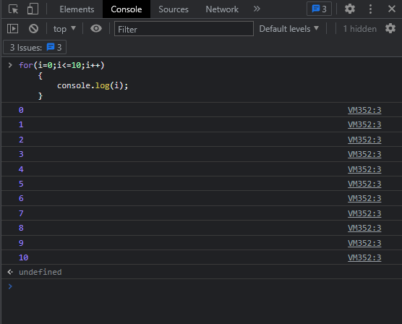

**2.Program to calculate the sum of first 10 numbers.**

**Solution :** let s=0;

for ( let I=0 ; I <= 10 ; I++ )

{

s = s + I ;

}

console.log(s);

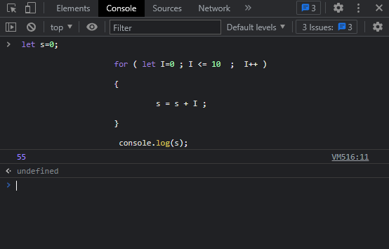

**3.** **Make the loop stop when i is 5.**

**for ( i = 0 ; i < 10 ; i++) {**  
 **console.log(i);**  
 **if (i == 5) {**   
  
**----------;**  
 **}**  
 **}**

**Solution :**  for ( let I=0 ; I <= 10 ; I++ )

{

If(I==5){

break;

}

console.log(I);

}

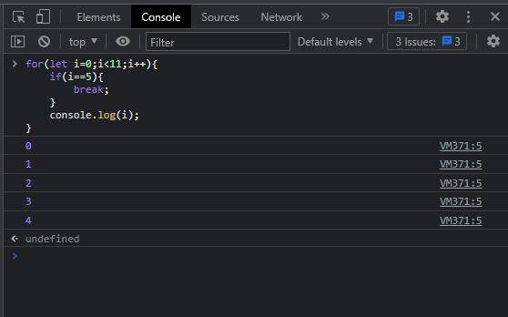

**4. Write a program to print day of week name using switch case.**

**Solution :**  let num=4;

Switch(number){

Case 0: print ‘Sunday’

Break;

Case 1: print ‘Monday’

Break;

Case 2: print ‘Tuesday’

Break;

Case 3: print ‘Wednesday’

Break;

Case 4: print ‘Thursday’

Break;

Case 5: print ‘Friday’

Break;

Case 6: print ‘Saturday’

Break;

Default :print ‘Invalid input’

Break;

}

Output : Thursday

**5. Write a program to print total number of days in a month using switch case.**

**Solution :**  let month=3;

Switch(month){

Case 1 : print ’31’

Break;

Case 2 : print ’28’

Break;

Case 3 : print ’31’

Break;

Case 4 : print ’30’

Break;

Case 5 : print ’31’

Break;

Case 6 : print ’30’

Break;

Case 7 : print ’31’

Break;

Case 8 : print ’31’

Break;

Case 9 : print ’30’

Break;

Case 10 : print ’31’

Break;

Case 11 : print ’30’

Break;

Case 12 : print ’31’

Break;

Default : print ‘Invalid Input’

Break;

**Output : ‘31’**